PRESS RELEASE
10th Anniversary of ERDE Initiative - Nationwide Take-back System for Agricultural Plastics in Germany 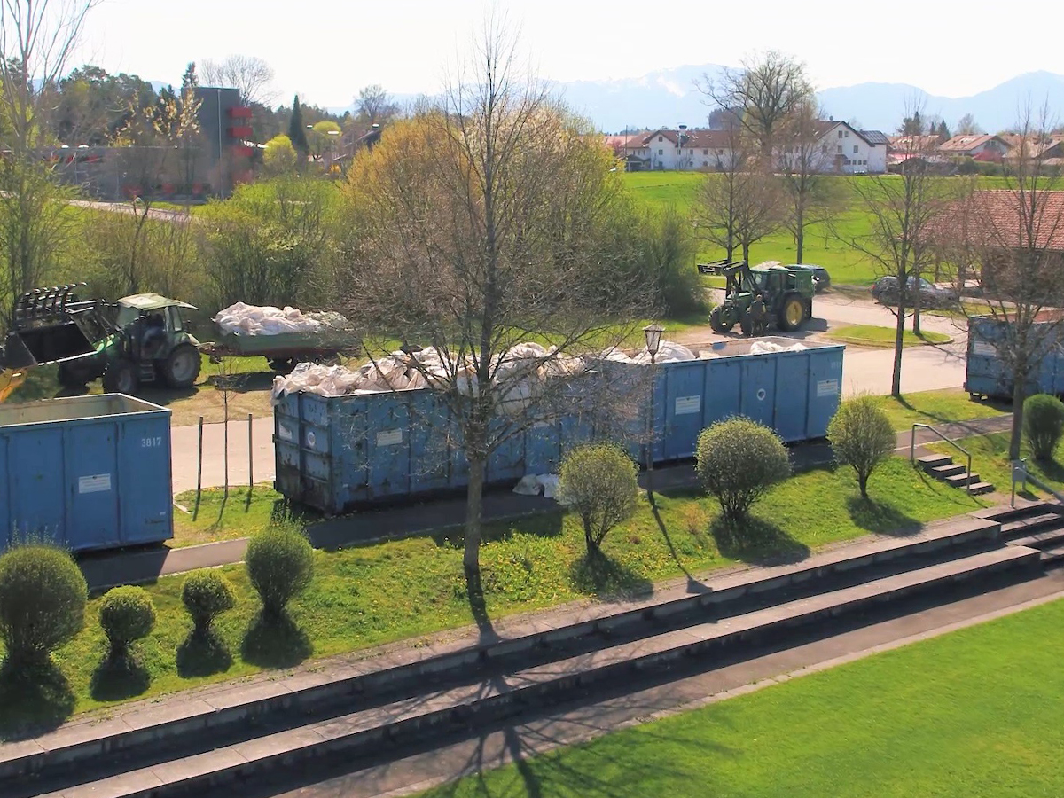
Separate takeback of agricultural plastics at ERDE collection points across Germany. © ERDE
Wiesbaden/Bad Homburg, August 2023
This year marks the 10th anniversary of the ERDE initiative, which proudly reflects on a successful decade as a nationwide take-back system for agricultural plastics in Germany. Since its establishment on July 31, 2013, by six manufacturers of agricultural plastics within the IK Industrievereinigung Kunststoffverpackungen e.V., the ERDE initiative has continuously strived to promote a circular economy for agricultural plastics and create a sustainable future for generations to come.
In collaboration with its cooperative partner RIGK GmbH, the ERDE Initiative has achieved significant milestones over the past ten years by establishing and successfully implementing a nationwide take-back system for agricultural plastics. The Initiative's voluntary commitment to the Federal Ministry for the Environment (Bundesumweltministerium – BMUV) was fulfilled last year, with over 65% of silo and stretch films being collected and recycled. The Initiative is now funded by 25 manufacturers of agricultural plastics from around the world. Through the dedicated efforts of farmers, contracting companies, traders, machinery rings, youth agricultural organizations, 100% partners, and numerous supporters, over 38,000 tons of used agricultural films, nets, yarns, and nonwovens were collected and recycled at a rate exceeding 95% last year alone. By repatriating plastics into the production cycle, valuable resources are conserved and CO2 emissions minimized - resulting in over 42,000 tons of CO2 saved in 2022.
"We are overwhelmed and grateful for the support we have received over the last ten years," says Dr. Lorena Fricke, Managing Director of the ERDE initiative. "With the backing of our members, environmentally-conscious companies, and farmers, we have successfully established an efficient and comprehensive system for the collection and recycling of agricultural plastics. This system significantly contributes to a circular economy and environmental protection. In the coming years, we aim to expand the collection network and include additional product categories in our collection portfolio."
The anniversary will be celebrated at this year's Agritechnica: The world's leading trade fair for agricultural technology will open its doors from November 12-18 in Hannover. Interested parties can learn about ERDE and engage in discussions with supporters from the entire agricultural industry at the ERDE booth in Hall 24, Stand B24, to chart the course for the ongoing success story.
About ERDE
Under the umbrella of the IK Industrievereinigung Kunststoffverpackungen e.V. and in cooperation with RIGK as system operator, ERDE organises the separate return and recycling of used crop plastics such as silage film, stretch film, asparagus film, perforated film, mulch film, non-wovens, bale nets and baler twine via collection partners throughout Germany. Contractors and farmers collect the crop plastics and hand them in bundled - broom-clean and freed of coarse dirt - at a collection point. The return fee is set directly by the collection point. Recycling companies then process the collected material into new plastic raw materials.
More information on members, 100% trade partners and participating brands can be found here.
Any manufacturer or primary distributor of crop plastics who supplies the German market can become a member of ERDE. The following 27 companies assume responsibility for their products and the environment as ERDE members: ape Europe, ASPLA S.A., Groupe Barbier, Berry bpi, Berry Fiberweb France, CLAAS Vertriebsgesellschaft mbH, Cordex - Companhia Industrial Textil S.A., Coveris Flexibles Austria GmbH, Daios Plastics S.A., DUOPLAST AG, KARATZIS S.A., Manupackaging Deutschland GmbH, NOVATEX, PIIppo OYJ, Plastika Kritis S.A., POLIFILM Extrusion GmbH, Ab Rani Plast Oy, Reyenvas S.A., RKW Agri GmbH & Co. KG, Sicor - Sociedade Industrial de Cordoaria S.A., Solplast S.A., Sotrafa S.A., Tama Group, Tecfil S.A., Tencate Geosynthetics, TRIOWORLD GmbH and WKI Tegafol Sp. z o.o-.
Further informationen:
IK Initiative ERDE
Dr. Lorena Fricke
Managing Director ERDE
Kaiser-Friedrich-Promenade 43
61348 Bad Homburg
Phone: +49 (0) 6172 92 66 30

