Press release
ERDE initiative ensures CO2 savings of 42,748 tons in 2022 through the collection of agricultural plastics
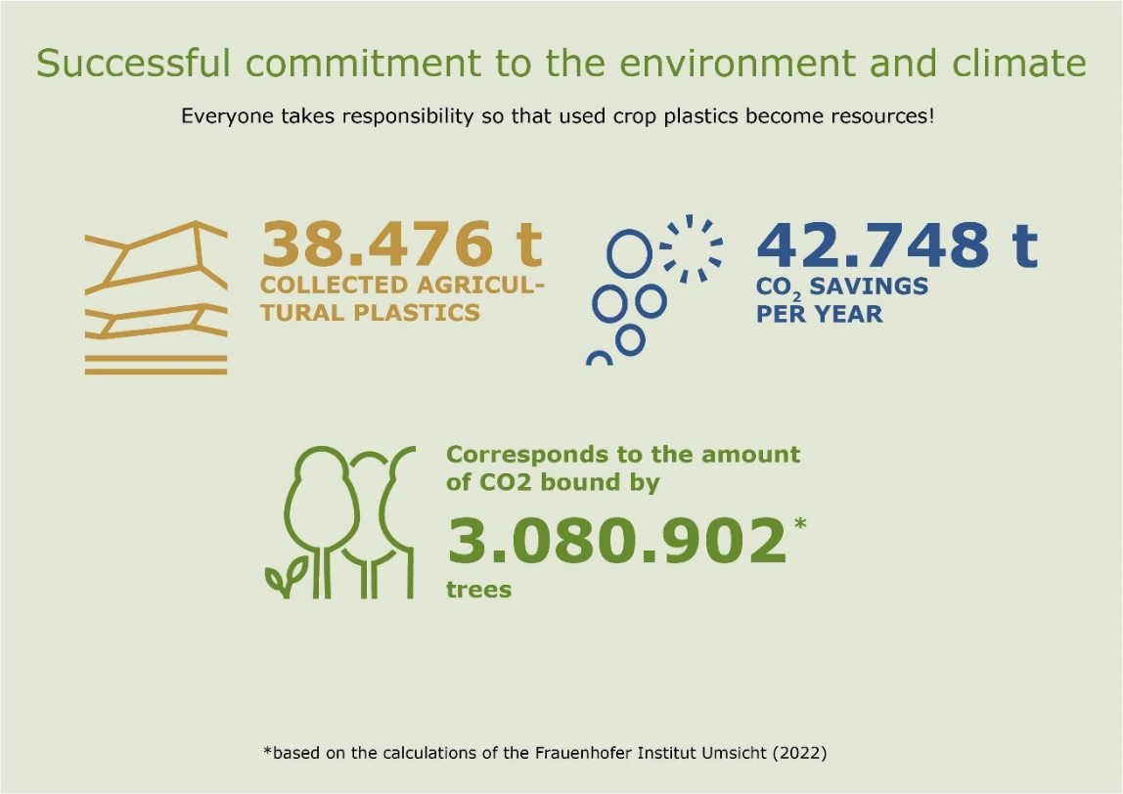
Agricultural plastics collected through ERDE Recycling have a significant impact on the environment and climate. © ERDE
Wiesbaden, Bad Homburg, April 2023
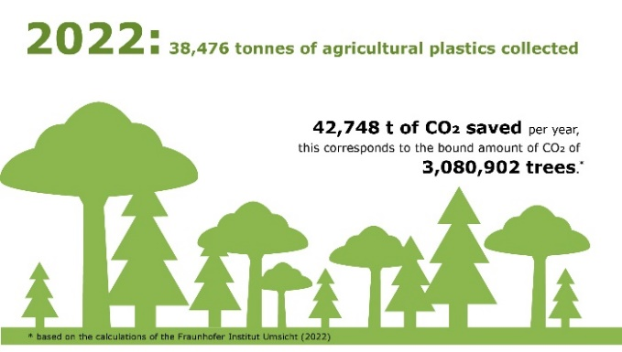
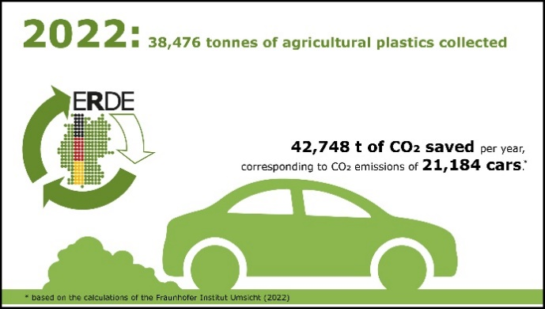
The 2023 ERDE collection period has been in full swing since mid-February, and the ERDE (Erntekunststoffe Recycling Deutschland) initiative has once again set ambitious goals for the new collection period. In advance, however, there is news to announce about the past season, which allows a very confident look into the coming period: in 2022, a total of 38,476 tons of agricultural plastics could be collected via ERDE Recycling - an increase of almost 18 percent compared to the previous year!
Calculating the CO2 savings achieved by recycling the 38,476 tons of agricultural plastics collected, the CO2 equivalent is 42,748 tons - also an increase of 20 percent over the previous year. This results in a saving this year that would tie up the equivalent of 21,184 cars traveling 290,799,441 km. Or, to put it another way, a saving that equivalents the amount of CO2 a total of 3,080,902 trees with a forest area of 4,275 ha would tie up. These figures are impressive and make a significant contribution to more sustainable agriculture and environmental protection - made possible by a joint and successful collaboration with all farms, participating producers and other partners.
As a sign of gratitude and appreciation, system operator RIGK, in cooperation with the Industrievereinigung Kunststoffverpackungen e.V. and the Fraunhofer Institute UMSICHT, issues climate protection certificates to participating manufacturers once a year through the ERDE initiative. These certificates show that the participation and commitment of the manufacturers in ERDE Recycling and the successful collection and recycling of the collected agricultural plastics in 2022 have contributed a considerable share to climate protection and the circular economy.
In this sense, however, RIGK and IK would like to thank all participants on behalf of ERDE Recycling for the good cooperation and hopes that the gratifying trend of increasing greenhouse gas savings in recent years can be successfully continued in the future!
About ERDE
Under the umbrella of IK Industrievereinigung Kunststoffverpackungen e.V. and in cooperation with system operator RIGK, ERDE organises the recovery and recycling of used crop plastics, such as silage film, stretch film, asparagus film, perforated film, bale nets, baler twine and PP non-wovens, through collection partners throughout Germany. Supply agencies and farmers collect the crop plastics, pack and deliver them – swept clean and free of the worst of the dirt – to a collection point (www.erde-recycling.de/rund-um-die-abgabe/sammelstellen-termine.html). Collection points set the collection prices individually. Recycling companies process the collected goods into new plastic feedstocks.
Any producer or distributor of crop plastics that supplies the German market can become an ERDE member. The following 25 ERDE members take responsibility for their products and the environment: ape Europe, ASPLA S.A., Groupe Barbier, Berry bpi, Berry Fiberweb France, CLAAS Vertriebsgesellschaft mbH, Cordex - Companhia Industrial Textil S.A., Coveris Flexibles Austria GmbH, Daios Plastics S.A., DUOPLAST AG, KARATZIS S.A., Manupackaging Deutschland GmbH, NOVATEX, PIIppo OYJ, Plastika Kritis S.A., POLIFILM Extrusion GmbH, Ab Rani Plast Oy, Reyenvas S.A., RKW Agri GmbH & Co. KG, Sicor - Sociedade Industrial de Cordoaria S.A., Solplast S.A., Sotrafa S.A., Tama Group, Tecfil S.A., Tencate Geosynthetics, TRIOWORLD GmbH und WKI Tegafol Sp. z o.o-

Further information:

Initiative ERDE
IK Industrievereinigung Kunststoffverpackungen e.V.
Dr. Lorena Managing Director ERDE
Kaiser-Friedrich-Promenade 43
61348 Bad Homburg
l.fricke(at)erde-recycling.de;
Phone: +49 (0) 6172 92 66 30

RIGK GmbH
Boris Emmel
System Manager ERDE
Friedrichstr. 6, D-65185 Wiesbaden
Phone.: +49 611 308600-20
emmel(at)rigk.de;
www.erde-recycling.de

