PRESS RELEASE
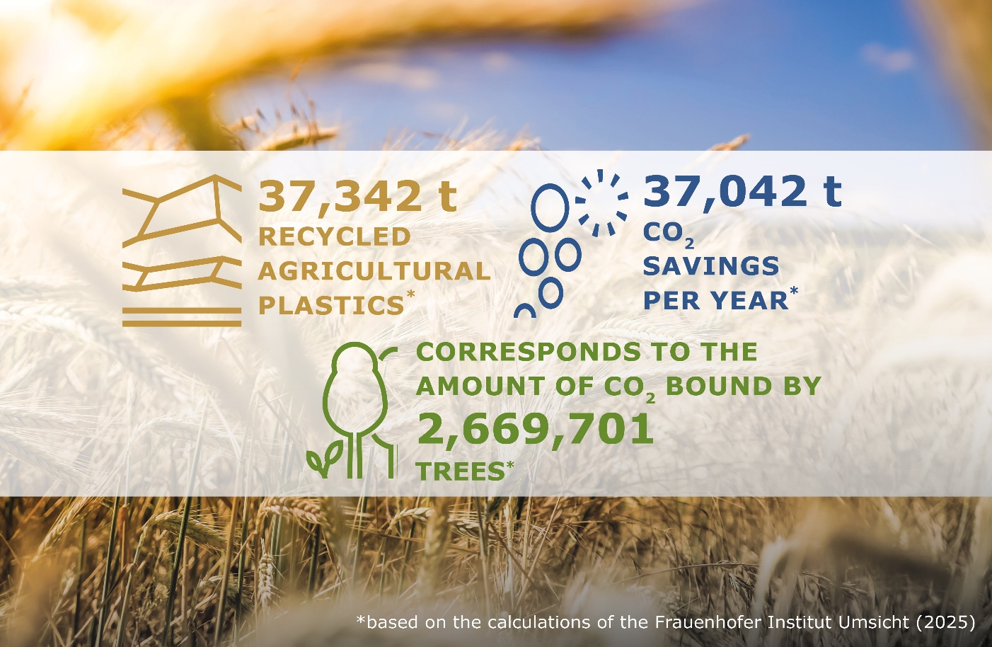
Successful 2025 Results: ERDE Initiative Recycles Over 37,000 Tonnes of Agricultural Plastics
Successful commitment to environmental and climate protection – turning used agricultural plastics into new resources. © RIGK / ERDE
Wiesbaden, April 2026 – The ERDE initiative (Erntekunststoffe Recycling Deutschland) continues its successful growth trajectory. In 2025, a total of 37,342 tonnes of agricultural plastics were collected and sent for material recycling within the take-back and recycling system established by RIGK and its partners.
Despite an overall reduction in market volumes, the initiative further increased its recycling input rate compared to the previous year, making the system even more efficient. ERDE has once again made a significant contribution to the circular economy in agriculture.
Recycling these materials resulted in savings of approximately 37,042 tonnes of CO₂ equivalents. This corresponds to around 350 million kilometres driven by passenger cars, the annual mileage of approximately 28,400 vehicles, or the carbon sequestration capacity of around 2.7 million trees.
“The results demonstrate that our system works in practice when all stakeholders pull together,” says Boris Emmel, System Manager of the ERDE initiative. “The high level of participation from agricultural businesses, trade and collection points shows that circular economy principles are increasingly being implemented in agriculture. Every returned agricultural plastic helps to keep valuable raw materials in circulation and sustainably reduce environmental impact.“
Shared responsibility across the value chain
The results of the ERDE collection campaign are the outcome of collaboration between numerous stakeholders. Under the umbrella of the IK Industrievereinigung Kunststoffverpackungen, manufacturers work together with RIGK GmbH as system operator, agricultural businesses, collection partners, recyclers and the agricultural trade to ensure a functioning take-back and recycling system.
The basis for this is the initiative’s voluntary commitment to the German Federal Ministry for the Environment. It defines concrete targets for the collection and recycling of agricultural plastics – including a collection rate of over 60% for asparagus films by 2026 and 75% for silage and stretch films by 2027.
Dr Laura C. Müller, Economic Affairs Advisor at IK Industrievereinigung Kunststoffverpackungen, emphasises: “The continuous progress shows that voluntary industry solutions can work in the spirit of the circular economy. ERDE is an example of how producer responsibility can be implemented in practice together with agriculture, trade and the recycling industry.“
Expansion of the take-back system – infrastructure and material streams growing
Alongside stable collection volumes, the initiative’s network continues to expand. With more than 700 collection points and over 160 collection partners, ERDE now provides a comprehensive infrastructure for the return of used agricultural plastics.
The collection portfolio is also continuously being expanded. Following successful pilot projects, greenhouse films and drip irrigation pipes have now been permanently integrated into the system. In addition, further manufacturers are joining the initiative, strengthening both the financing and ongoing development of the system.
Strengthening the circular (agricultural) economy and European exchange
ERDE aims to continue its successful path in the coming years. The goal remains to further increase collection volumes and continuously expand the network across the agricultural value chain.
At the same time, the initiative is increasingly engaged in international dialogue on take-back and recycling systems for agricultural plastics. Exchange with industry stakeholders and national initiatives across Europe is intended to help share best practices and further advance the circular economy in the agricultural sector.

Further information:  Initiative ERDE  Boris Emmel, System Manager  Friedrichstr. 6  65185 Wiesbaden (Germany)  Phone: +49 611 308600-20  emmel@rigk.de, www.erde-recycling.de | Editorial contact, review copies:  Konsens PR GmbH & Co. KG  Dr.-Ing. Jörg Wolters  Hans-Böckler-Straße 20  63811 Stockstadt (Germany)  Phone: +49 6027/99005-13  mail@konsens.de; www.konsens.de
You can download this press release as a DOC file, along with the image in print-ready resolution, from www.rigk.de/en/worth-knowing/press

