PRESSEMITTEILUNG

ERDE Initiative Celebrates Its 10th Anniversary at Agritechnica

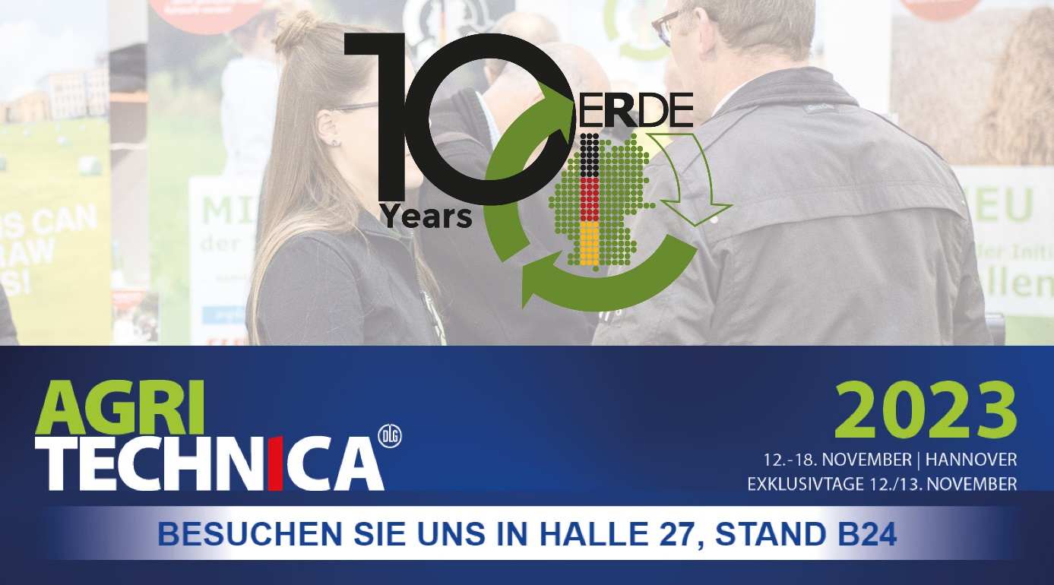
Wiesbaden/Bad Homburg, November 2023 - This year, the ERDE Initiative, operated under the umbrella of the IK (Industrievereinigung Kunststoffverpackungen e.V.), is not only marking significant achievements but also celebrates its 10th anniversary. Founded in 2013, ERDE has made substantial progress over the past decade in promoting the circular economy for agricultural plastics and environmental protection. This milestone will be celebrated at this year's Agritechnica!
The world's leading trade fair for agricultural machinery will take place from November 12th to 18th, 2023, in Hannover, and ERDE will be present with a booth.

Visitors to the booth in Hall 27, Stand B24, will have the opportunity to learn about ERDE and engage in discussions with supporters from across the agricultural industry on how to continue the success story in the years to come.
In 2022, ERDE achieved a significant milestone when over 65 percent of silo and stretch films were collected and recycled as part of a voluntary commitment. This achievement was made possible through the support of 25 manufacturers of agricultural plastics from around the world and the active involvement of farmers, contracting companies, traders, machinery rings, agricultural youth organizations, 100% partners, and numerous supporters. In total, over 38,000 tons of used agricultural films, nets, yarns, and nonwovens were collected and recycled to over 95 percent. This led to over 42,000 tons of CO2 saved in 2022.
Dr. Lorena Fricke, the Managing Director of the ERDE Initiative, is overwhelmed by the support and emphasizes that ERDE has established an efficient and comprehensive system for the collection and recycling of agricultural plastics, making a significant contribution to a more sustainable agriculture:
"Over the past 10 years, the ERDE Initiative has shown that sustainable solutions for environmental issues can be found through collaborative efforts in agriculture. The 10th anniversary marks another step in this direction. We want to celebrate this at Agritechnica with all stakeholders and, of course, look forward to the future!"

ERDE has ambitious goals for the future, including expanding the collection network and incorporating additional product categories into the collection portfolio. Boris Emmel, System Manager ERDE, confirms, "The 10th anniversary is not just a time to look back on past successes but also an inspiration for ERDE to continue its efforts to promote a conscious and sustainable use of resources in agriculture."
ERDE warmly invites all Agritechnica visitors to stop by Booth B24 in Hall 27 and join in the collective effort for a sustainable future in agriculture.
About ERDE
Under the umbrella of the IK Industrievereinigung Kunststoffverpackungen e.V. and in cooperation with RIGK as system operator, ERDE organises the separate return and recycling of used crop plastics such as silage film, stretch film, asparagus film, perforated film, mulch film, non-wovens, bale nets and baler twine via collection partners throughout Germany. Contractors and farmers collect the crop plastics and hand them in bundled - broom-clean and freed of coarse dirt - at a collection point. The return fee is set directly by the collection point. Recycling companies then process the collected material into new plastic raw materials.
More information on members, 100% distribution partners and participating brands can be found here.
Any manufacturer or primary distributor of crop plastics who supplies the German market can become a member of ERDE. The following 27 companies assume responsibility for their products and the environment as ERDE members: ape Europe, ASPLA S.A., Groupe Barbier, Berry bpi, Berry Fiberweb France, CLAAS Vertriebsgesellschaft mbH, Cordex - Companhia Industrial Textil S.A., Coveris Flexibles Austria GmbH, Daios Plastics S.A., DUOPLAST AG, KARATZIS S.A., Manupackaging Deutschland GmbH, NOVATEX, PIIppo OYJ, Plastika Kritis S.A., POLIFILM Extrusion GmbH, Ab Rani Plast Oy, Reyenvas S.A., RKW Agri GmbH & Co. KG, Sicor - Sociedade Industrial de Cordoaria S.A., Solplast S.A., Sotrafa S.A., Tama Group, Tecfil S.A., Tencate Geosynthetics, TRIOWORLD GmbH and WKI Tegafol Sp. z o.o-.

Further information:
IK Initiative ERDE
Dr Lorena Fricke
Managing Director ERDE
Kaiser Friedrich Promenade 43
61348 Bad Homburg
Phone: +49 (0) 6172 92 66 30

