PRESS RELEASE
ERDE Switzerland collects over 1,800 tonnes of agricultural plastics in its first year
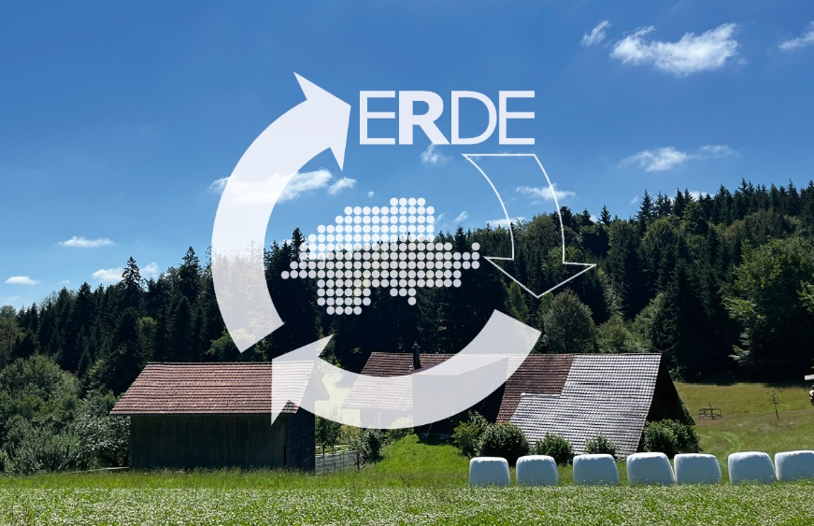
ERDE Switzerland has completed its first year as a take-back system for agricultural plastics in Switzerland – and has achieved impressive success. ©ERDE Switzerland
The take-back system was able to exceed the set target and collect over 1,800 tonnes of plastics that were sent off directly for recycling.
At the beginning of 2022, ERDE Switzerland began collecting used agricultural plastics that had accumulated in Switzerland – and is enthusiastic about the feedback it’s received. The self-imposed take-back target of 1,200 tonnes was exceeded, as the system collected over 1,820 tonnes of agricultural plastics in this initial collection period. The used silage films, stretch films and nets are recycled in Switzerland and in other recycling plants in the EU. The collection and recycling process is confirmed by an independent auditor and a report is issued certifying the recycling of the collected films.
Kurt Röschli, the President of ERDE Switzerland, points out that “recycling this volume of plastic amounts to a reduction of more than 2,000 tonnes of CO2.”
For the upcoming season, the network of around 100 collection points is to be expanded and the volume of agricultural plastics to be taken back will be further increased. Together with the participating farms, manufacturers and other partners, ERDE Switzerland will thus continue to make a major contribution to the promotion of a sustainable and effective circular economy.
About ERDE Switzerland
An estimated 6,000 tonnes of agricultural plastics are used annually in Switzerland. In order to reduce the entry of plastics from the agricultural sector into the environment and to promote recycling, KUNSTSTOFF.swiss (the association of the Swiss plastics industry), members of the German ERDE Initiative, RIGK as system operator and other supporters from Switzerland founded the independent association ERDE Switzerland on 14 July 2021. The system has been operational since 1 January last year, and since the official start of collections in April 2022, agricultural plastics in Switzerland can be dropped off at collection points and sent for recycling. More information about ERDE Switzerland can be found here.

Contact ERDE Schweiz:  c/o KUNSTSTOFF.swiss  Kurt Röschli, Geschäftsführer  Verena Jucker, Leiterin Kommunikation  Schachenallee 29C, CH-5000 Aarau  Phone: +41 62 834 00 60  info(at)erde-schweiz.ch;  https://kunststoff.swiss | Further informationen ERDE Initiative:  RIGK GmbH  Boris Emmel  System Manager ERDE  Friedrichstr. 6, D-65185 Wiesbaden  Phone: +49 611 308600-20  emmel(at)rigk.de;  ERDE-Recycling
You can find this press release as a doc file as well as the pictures in printable resolution for download at www.rigk.de/wissenswert/presse

