PRESS RELEASE

Voluntary commitment to the BMUV: IK-initiative "Erntekunststoffe Recycling Deutschland" (ERDE) renews its recovery commitment

Wiesbaden/Berlin, Januar 2024 - Bettina Hoffmann, Parliamentary State Secretary at the BMUV, accepted the new voluntary commitment of the ERDE initiative in the context of the Green Week on 19 January 2024. The companies in the initiative have pledged to collect and recycle over 60 per cent of all asparagus film placed on the market in Germany by 2026 and over 75 per cent of all silage and stretch film by 2027. ERDE members have also committed to specific collection targets for other agricultural plastics such as nets, yarns and nonwovens. In addition, further crop plastics are to be included in the take-back and recycling system in future. In the coming years up to 2027, drip tapes, greenhouse film and protective nets will also be integrated into the cycle. ERDE is thus aiming for a holistic recycling solution for all crop plastics.

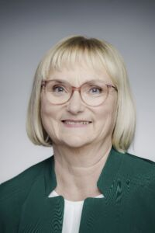
Parliamentary State Secretary Bettina Hoffmann: "The ERDE initiative makes a major contribution to protecting our environment. The collection and recycling of used crop plastics is an important contribution to reducing plastic littering in the environment. The manufacturers and farmers in the ERDE initiative are now expanding their voluntary commitment to include further agricultural plastics and specific collection targets. With their commitment to finding high-quality recycling processes for all agricultural plastics, farmers and manufacturers are impressively demonstrating their responsibility for the environment."
© Bundesregierung / Jesco Denzel

Lorena Fricke, ERDE Managing Director: "Together with farmers and our partners from the distribution sector, contractors and waste disposal companies, we want to ensure that all agricultural plastics in Germany are collected and recycled – to close the material cycle and prevent plastics from entering the environment. The financial commitment of manufacturers and distributors makes it possible to create cost-effective recovery options for used agricultural plastics throughout Germany. This is extended product responsibility in action. ERDE was even able to significantly exceed the first voluntary self-commitment to the BMUV from 2019. We are confident that we will also be able to meet the ambitious requirements of the renewed commitment."
© ERDE-Recycling

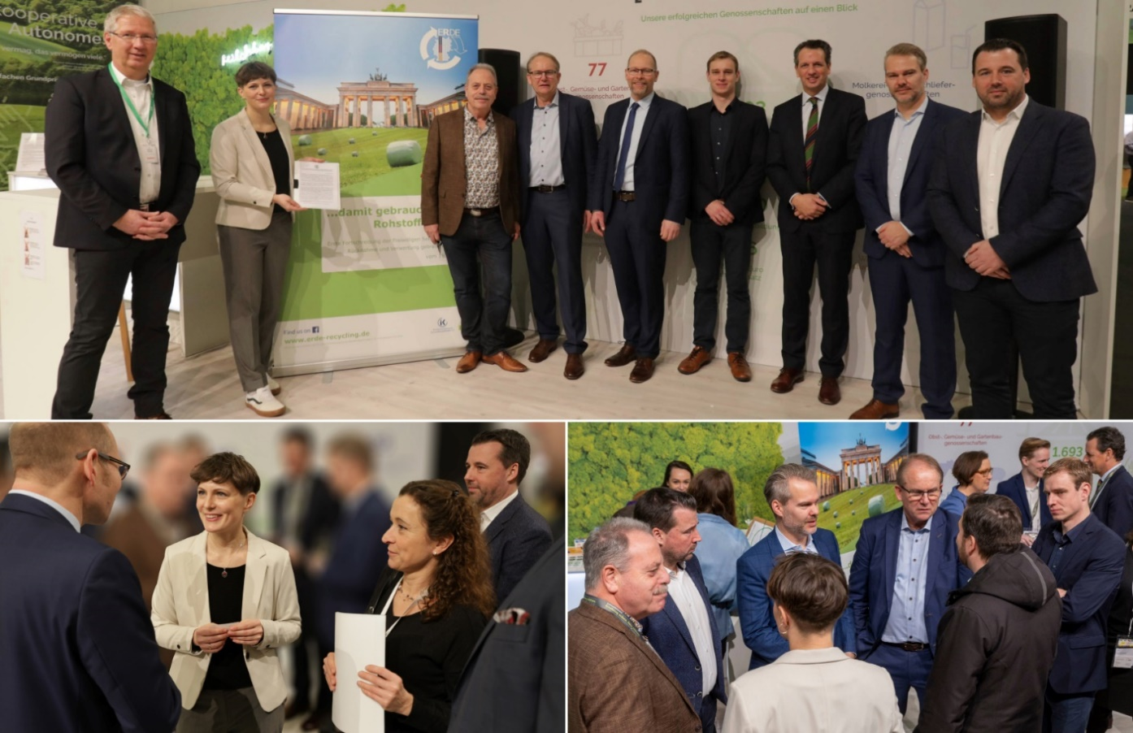
Impressions from the presentation of the new voluntary commitment by the ERDE Initiative at the Green Week in Berlin, featuring the endorsing entities. In Picture 1 (from left to right): Dr. Hartmut Matthes (Managing Director of the Bundesverband Lohnunternehmen e.V.), Dr. Lorena Fricke (ERDE Managing Director), Dr. Reininger (Expert in Agricultural Inputs at the Deutscher Raiffeisenverband e.V.), Franz-Josef Lichte (ERDE Board Member), Dr. Christian Weseloh (Managing Director of the Bundesvereinigung der Erzeugerorganisationen Obst und Gemüse e.V.), Raphael Linka (Head of Sales Agri DACH Trioworld), Dr. Philipp Spinne (Managing Director of the Deutscher Raiffeisenverbandes e.V., Jan Bauer (Managing Director RIGK GmbH) and Boris Emmel (System Manager ERDE).
Films are mainly used in fruit and vegetable cultivation to protect against weather influences such as frost, hail or drought. The moist microclimate under the film also allows plants such as asparagus or parsley to grow faster. In the feed sector, films ensure high-quality, long-lasting animal feed and minimise feed losses. However, lost agricultural film can pollute the environment. This is why the manufacturers of agricultural plastics are taking responsibility: They want to ensure that as many of the products they place on the market as possible are taken back and recycled.

The IK initiative ERDE was originally founded in 2013 by six film manufacturers. RIGK GmbH acts as the system operator for ERDE and the IK Industrievereinigung Kunststoffverpackungen e.V. is the umbrella organisation for the initiative.

The participating companies more than fulfilled their first voluntary commitment from 2019: As a result, over 68 per cent of silage and stretch film from ERDE and over 41 per cent of asparagus film has been collected so far. Bale nets, baler twine, perforated film, mulch film and non-wovens are collected at a total of over 645 collection points and 3147 mobile collections. In 2022, this amounted to a total of over 38,467 tonnes of agricultural plastics, 95% of which were recycled. Around 66 per cent of the agricultural film collected is recycled in Germany, the remaining 34 per cent in other EU countries. The used films become valuable raw materials, for new agricultural and construction films, irrigation hoses and bin liners. The provision of recycled material saved over 42,748 tonnes of CO2 in 2022.

In addition to the ERDE initiative, signatories to the voluntary commitment include IK Industrievereinigung Kunststoffverpackungen e.V., Deutscher Raiffeisenverband e.V., Der Agrarhandel e.V., BLU Bundesverband Lohnunternehmen e.V., Netzwerk der Spargel- und Beerenverbände e.V. and BVEO Bundesvereinigung der Erzeugerorganisationen Obst und Gemüse e.V..

Co-signatory Martin Courbier, Managing Director of Der Agrarhandel e.V., emphasises: "The aim of ERDE is to provide a Germany-wide disposal service for farmers. This can only work if manufacturers, distributors and farmers work closely together. Our companies are aware of their responsibility for the sustainable use of resources, are committed to the ERDE initiative and are creating more and more collection points.“

© BVA
Further information:
About ERDE
Under the umbrella of the IK Industrievereinigung Kunststoffverpackungen e.V. and in cooperation with RIGK as system operator, ERDE organises the separate return and recycling of used crop plastics such as silage film, stretch film, asparagus film, perforated film, mulch film, non-wovens, bale nets and baler twine via collection partners throughout Germany. Contractors and farmers collect the crop plastics and hand them in bundled - broom-clean and freed of coarse dirt - at a collection point. The return fee is set directly by the collection point. Recycling companies then process the collected material into new plastic raw materials.
More information on members, 100% distribution partners and participating brands can be found here.
Any manufacturer or primary distributor of crop plastics who supplies the German market can become a member of ERDE. The following 27 companies assume responsibility for their products and the environment as ERDE members: ape Europe, ASPLA S.A., Groupe Barbier, Berry bpi, Berry Fiberweb France, CLAAS Vertriebsgesellschaft mbH, Cordex - Companhia Industrial Textil S.A., Coveris Flexibles Austria GmbH, Daios Plastics S.A., DUOPLAST AG, KARATZIS S.A., Manupackaging Deutschland GmbH, NOVATEX, PIIppo OYJ, Plastika Kritis S.A., Ab Rani Plast Oy, Reyenvas S.A., RKW Agri GmbH & Co. KG, Sicor - Sociedade Industrial de Cordoaria S.A., Solplast S.A., Sotrafa S.A., Tama Group, Tecfil S.A., Tencate Geosynthetics, TRIOWORLD GmbH and WKI Tegafol Sp. z o.o and XES GmbH.

Contact:
Initiative ERDE / IK Industrievereinigung Kunststoffverpackungen e.V.
Dr. Lorena Fricke, Managing Director ERDE
Kaiser-Friedrich-Promenade 43
61348 Bad Homburg
Phone: +49 (0) 6172 92 66 30

